# Matter Device Certification Requirements

## Certification Process

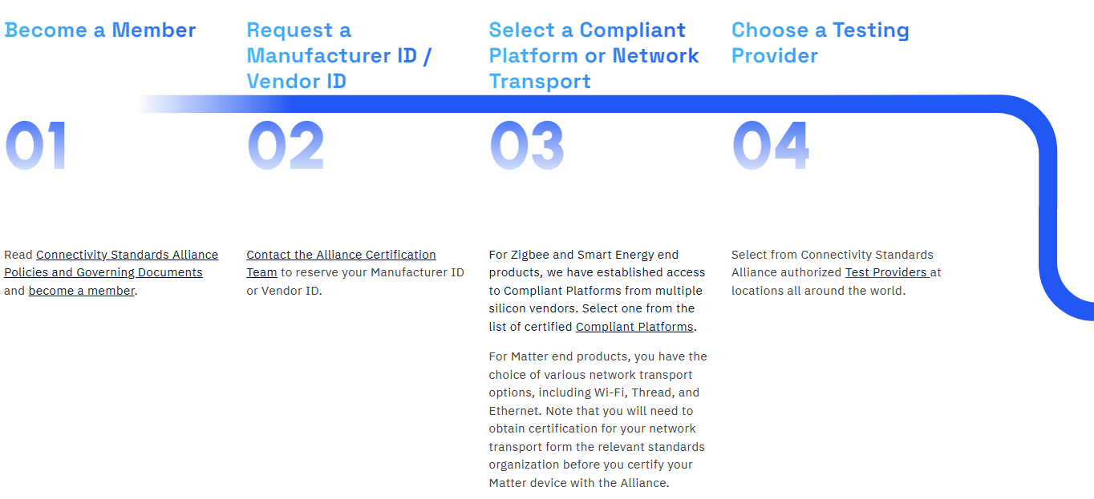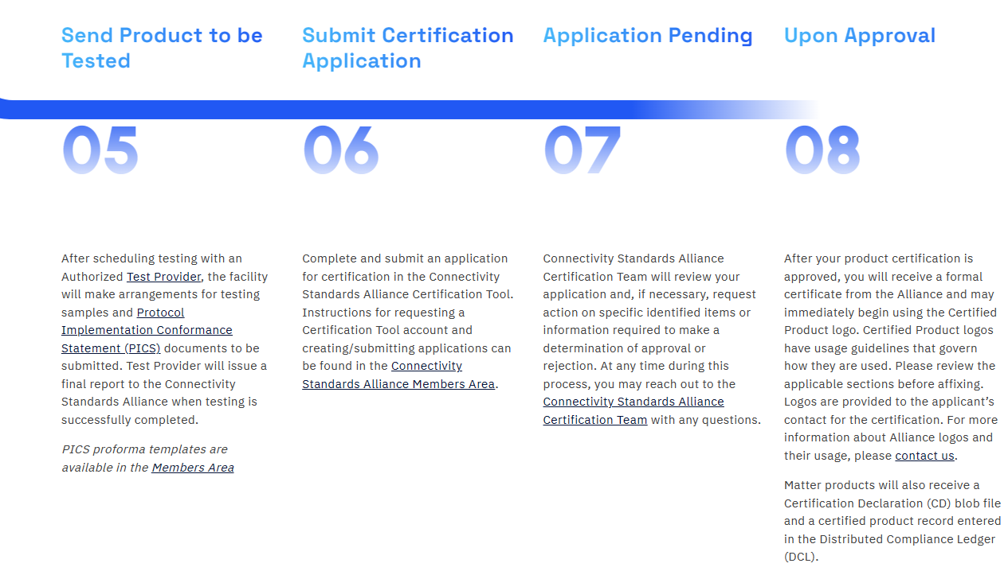

## Membership types:

### Associate members

The company **don’t manufacture the products**, instead the company OEM with 3rd party. To do this, the company must partner with existing Alliance ecosystems through **Certification Transfer Program.** As an associate member, the company is eligible to **White label or rebrand a Certified Product via the Associate Certification Tool and use the Alliance Certification trademarks for $2,500 USD per product + $500 USD per year, per product** (due annually on the anniversary date of the grant of certification)

### Adopter members

The company **use existing specifications to build products, certify the products, and use the Alliance logos and trademarks**. However, the company won’t be able to contribute on CSA specifications and developments. For an adopter, the company is eligible to **White label or rebrand a Certified Product via the Certification Tool and use the Alliance Certification trademarks for $2,500 USD per product.** Some notable companies include Accenture, Acer, Amlogic, Arduino, Capgemini, Gigadevice, Hyundai, Nokia,

### Participant members

Have authority to develop the specifications standard along with Alliance working group, gain early access to draft specifications, and can deliver to the market faster. The company can also use the standards for their products. As for participant, the company can **Enroll Certified Products in the Certified Transfer Program via the Certification Tool**, and **White label or rebrand a Certified Product via the Certification Tool and use the Alliance Certification trademarks for $1,500 USD per product.** Some notable companies are including Karcher, ARM, Bosch, Bose, Ubuntu, Cisco, Coway, Daikin, Dyson, Ford, GE Lighting, EZViz, Hisense, Intel, Microchip, Logitech, Mitshubishi, Murata, Panasonic, Qualcomm, Quectel, Renesas, Sharp, Thales, Toshiba, TUV, Vivo, Xiaomi,

### Promoter members

Gain all other member level benefits, including contribute to, develop and adopt the Alliance standards. The company also help to approve the standards, and participate as the Alliance Board of Directors and Board Committes. For promoter membership, the company can **Enroll Certified Products in the Certified Transfer Program via the Certification Tool**, and **White label or rebrand a Certified Product via the Certification Tool and use the Alliance Certification trademarks for $1,500 USD per product.** Some noticeable companies are including Amazon, Apple, Espressif, Google, Haier, Huawei, Infineon, LG, Midea, NXP, Nordic, Oppo, Samsung, Schneider, Siemens, ST Microelectronics, Tuya, and many more.

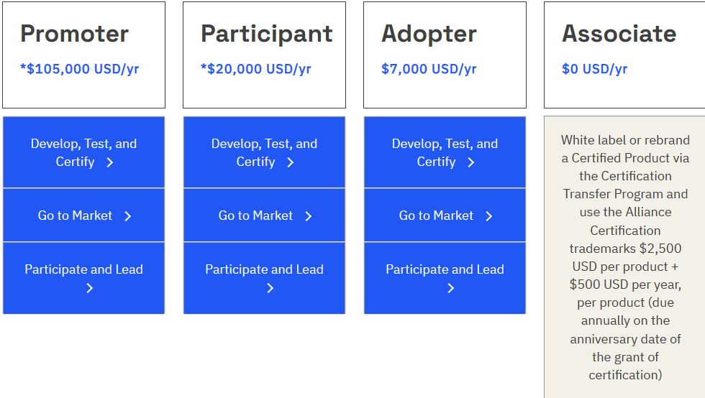

## Steps to become a member

## 

## Compliant Platform or Network Certification

### OpenThread



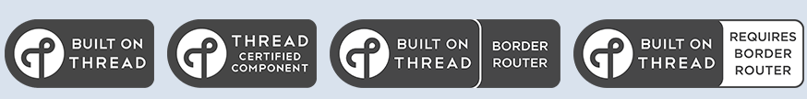

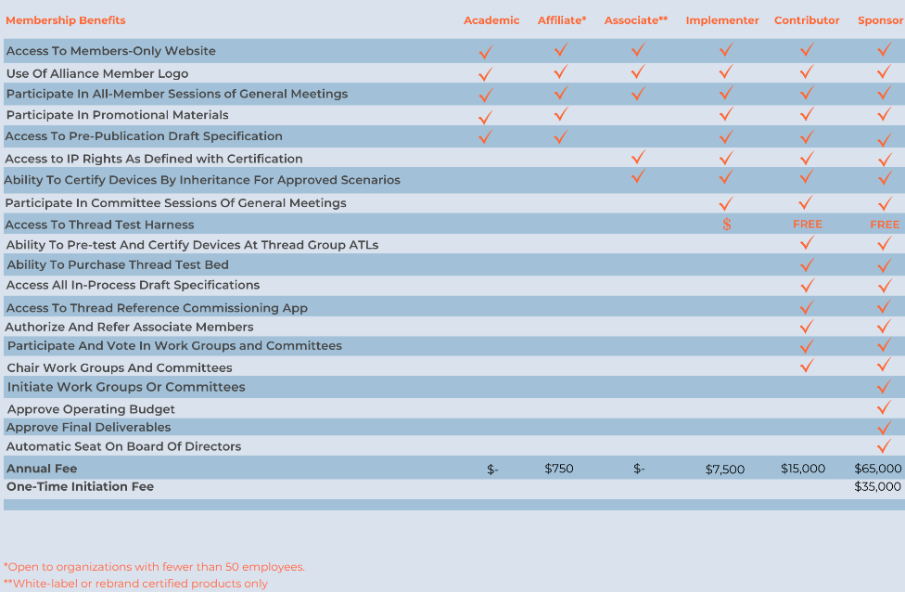

### WiFi

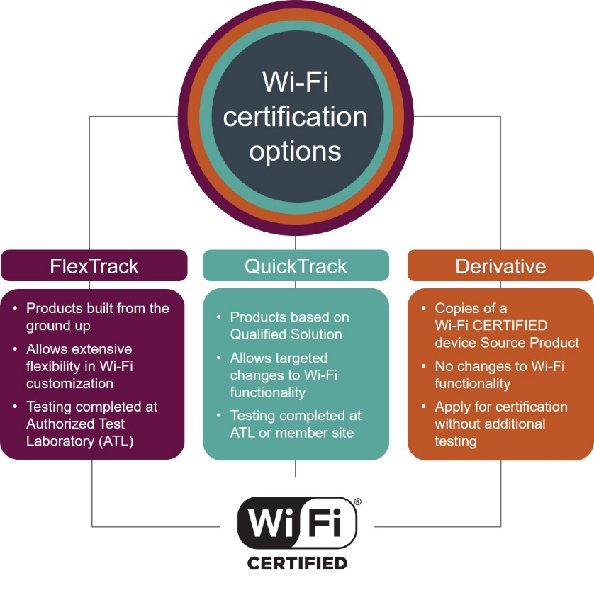

## CSA Testing Provider

|  |  |  |
| --- | --- | --- |
| **Japan**  Allion (Japan)  Allion  TÜV Rheinland (Shenzhen) Co., Ltd.  TUV | **Korea**  TÜV Rheinland (Shenzhen) Co., Ltd.  TUV  Granite River Labs (Korea)  Granite River Labs | **China/Taiwan**  UL Solutions (China)  UL Solutions  Bureau Veritas (China)  Bureau Veritas  DEKRA Testing and Certification (Shanghai) Ltd – Guangzhou Branch  Dekra  Element Material Technology (China)  Element Material Technology  Resillion (China)  Resillion  TÜV Rheinland (Shenzhen) Co., Ltd.  TUV |

## Certification Programs

* End products (Commercial use)
* Software Component – It used for User Interface Component (UIC) (i.e. application) or underlying software components (I.e. OS-specific library).
* Compliant Platforms – For Zigbee end product
* Certification Transfer Program – Certify the OEM products with the new brand.

## Certification Tools

Using PICS (Protocol Implementation Conformance Statement) tool – A web-based user interface to read and write XML PICS documents.

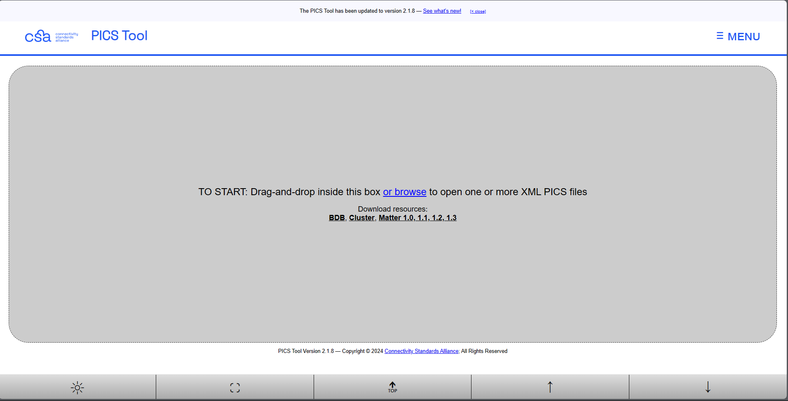

## Product Attestation Authorities (PAA)

This ensure that each certificate is legitimate and meets the requriements of the Matter specification. A non-VID (Vendor ID) offers the service of its well-established Public Key Infrastructure (PKI) provider to other member. An established PKI provider guarantees compliance with the Alliance PKI Certificate Policy and removes the need of implementing, submitting, and maintaining a Certification Authority. Some PAA include: DigiCert, Espressif, NXP, Tuya, and many more.

# References

1. [Certification Process | Why Certify | - CSA-IOT](https://csa-iot.org/certification/why-certify/)
2. [Become a Member | The Future of IOT - CSA-IOT](https://csa-iot.org/become-member/)
3. [Certification (threadgroup.org)](https://www.threadgroup.org/What-is-Thread/Certification)
4. [Certification | Wi-Fi Alliance](https://www.wi-fi.org/certification)
5. [PICS Tool v2.1.8 - Connectivity Standards Alliance (csa-iot.org)](https://picstool.csa-iot.org/)